You should design a cover page that is illustrative of your project. This page should have some descriptive figures or pictures as well as your project title.

Engineering Project Final Report

{Rankster}

Submitted by

Kanticha Raksasaksakul | 6538002321
Mawanta Rojanaprapa | 6538160821
Saharat Nuamchit | 6538208321

Approved by:

Project Advisor | : | Asst. Prof. Sukree Sinthupinyo, Ph.D.
Project Committee Member | : | Aung Pyae, Ph.D.
Project Committee Member | : | Assoc. Prof. Charnchai Pluempittiwiriyawej, Ph.D

ABSTRACT
This project presents the design and development of a novel social media platform that enables users to express their preferences through structured ranking-based content. The importance of this work lies in addressing a growing need for more meaningful and comparative forms of digital expression beyond traditional text, image, and video posts. Existing social media platforms do not natively support ranking as a core content format, leading users to rely on external tools and share static outputs across multiple platforms, resulting in a fragmented user experience and reduced engagement.
To solve this problem, this project proposes an integrated system that combines a tier-list creation tool with a social networking environment. The platform is developed using a user-centered design approach and modern frontend technologies, including Next.js, React, and Tailwind CSS, to ensure scalability and responsiveness. Key features include a ranking creation system, a personalized main feed, a search and trending discovery page, a personal board for tracking user activity, and social interaction functions such as likes, comments, and sharing.
The resulting system demonstrates the feasibility of integrating structured content creation with social interaction within a single platform, improving user engagement and content discoverability. Furthermore, the structured nature of ranking data enables potential future applications in data analytics and recommendation systems. Overall, this project contributes to the development of next-generation social platforms by redefining how users create, share, and interact with preference-based content.

TABLE OF CONTENTS

1 INTRODUCTION 1
2 BACKGROUND 2
3 DESIGN REQUIREMENTS 3
4 DESIGN DESCRIPTION 4
4.1 Overview 4
4.2 Detailed Description 4
4.3 Use 4
5 EXPERIMENTAL SETUP AND METHODS 5
5.1 Experimental Setup 5
5.2 Experimental Methods 6
6 RESULTS AND DISCUSSION 6
6.1 Results 6
6.2 Discussion 7
7 Project Global Impact 8
8 CONCLUSIONS 9
8.1 Assessment 10
8.2 Next Steps 10
9 REFERENCES 11

LIST OF FIGURES

Figure 6.1: Measured and calculated efficiency for Motor 3. The points represent measured efficiency for motor voltage of 4 V (green), 8 V (red), and 12 V (blue). The solid curves are the calculated efficiency for the model parameters determined as described above: R_{a} = 2.93 W, T₀ = 0.25 mN-m, and K_{e} = 11 mrad/Vs. 12
Figure 6.2: Sample Useless Table. Note the suspicious number of zeros. (Watch also for repetitive 100s when expressing percent). 14

LIST OF TABLES

Table 6.1: Guidelines for plots in reports 13

INTRODUCTION
The rapid evolution of social media platforms has significantly transformed how individuals express opinions and interact within digital communities. Modern platforms such as Instagram, Twitter, and TikTok enable users to share content in the form of text, images, and videos. However, these formats are inherently unstructured and do not effectively support comparative or preference-based expressions such as rankings or tier lists.
In recent years, ranking-based content has gained popularity across various domains, including entertainment, food, gaming, and lifestyle. Users frequently create “Top 10 lists” or tier rankings to communicate their preferences. Despite this trend, current platforms do not provide native tools to support structured ranking creation. Consequently, users rely on external tools to generate rankings and share them as static images on social media, resulting in a fragmented user experience and limited interaction.
This project aims to address this gap by developing a dedicated social media platform centered around ranking-based content. The proposed system integrates a tier-list creation tool with a community-driven social environment, allowing users to create, share, and interact with rankings seamlessly within a single platform.
The system adopts a user-centered design approach and leverages modern frontend technologies, including Next.js, React, and Tailwind CSS, to ensure a scalable and responsive user experience. By redefining rankings as a primary content type, this platform seeks to enhance user engagement, improve content discoverability, and enable richer forms of digital expression.

BACKGROUND
The increasing demand for structured content in digital platforms reflects a shift in how users prefer to express opinions and preferences. Traditional social media platforms primarily support unstructured formats, which are effective for storytelling but less suitable for comparative analysis or ranking-based expression. As a result, users have turned to third-party tools such as tier list generators and spreadsheets to create rankings.
However, these tools function mainly as standalone content generators and lack integrated social interaction features. Users must export their rankings as images and share them on separate platforms, where interaction is limited to comments or reactions disconnected from the original structure of the ranking. This separation reduces engagement, makes content difficult to interpret, and limits discoverability.
Existing platforms partially address this problem but remain incomplete. For example, some applications provide rating or list-based systems within specific domains, such as movies or restaurants, but they lack flexibility across multiple categories. Others support social interaction but do not provide structured ranking tools. As a result, the current ecosystem remains fragmented.
Furthermore, the lack of structured data in traditional social media limits opportunities for advanced analytics and recommendation systems. Ranking-based content, when properly structured and categorized, can provide valuable insights into user preferences and trends.
Therefore, there is a clear need for an integrated platform that combines ranking creation, social interaction, and content discovery into a single system. This project builds upon this need by proposing a unified solution that enhances both user experience and data-driven capabilities.

3. Design Requirements
3.1. User Research and Findings
The aim of the user research was to understand the pain points and behaviors of users who regularly express opinions and share preferences online. Initial research was conducted through interviews and online surveys targeting university students, hobby communities, food and entertainment enthusiasts, and casual social media users.
Based on the research, respondents consistently reported several challenges within the current digital landscape:
- Existing tools allow for the creation of rankings but lack integrated sharing or engagement features.
- When rankings are shared as screenshots on other platforms, they often lose their structure and become difficult for viewers to understand.
- Discovering rankings created by other users requires navigating across multiple fragmented platforms.
- Users have a strong interest in expressing preferences but desire a more streamlined and visually appealing tool to do so.
To guide the functional and design decisions, three representative personas were developed from the user research:
- Casual User: Enjoys discovering recommendations for food, movies, or lifestyle content.
- Ranking Enthusiast: Regularly creates lists, compares preferences, and participates in online trends.
- Business/Marketer: Interested in customer feedback, product testing, and market research using ranking formats.
These findings confirm the pressing need for a cohesive, user-centered system that natively supports both the creation of structured rankings and social interaction.
3.2. Market Research and Findings The market research focuses on the intersection of social media ecosystems and Big Data analytics. While social media plays a massive role in shaping how individuals express preferences, there remains a persistent gap in supporting structured forms of expression, like rankings and tier lists. The rise of ranking culture is well-documented across entertainment, consumer behavior, and hobbyist communities, highlighting that systematic comparison enhances clarity and encourages discussion.
From a market potential perspective, structured user preferences (such as tags, categories, and interactions) are highly valuable for deriving customer insights, identifying trends, and supporting data-driven recommendation systems. This presents an untapped opportunity to combine community interaction with Big Data analytics. Furthermore, a specialized ranking platform enables the exploration of a "Survey-as-Ad" business model. This approach allows businesses to access anonymized, aggregated market insights through voluntary surveys, promoting a sustainable digital economy without relying on intrusive advertising.
3.3. Competitor Analysis and Findings A comparison of relevant platforms was conducted to identify the strengths and missing capabilities in the current market. The competitive landscape highlights a clear gap: no existing platform provides a unified environment for ranking creation, social interaction, and data-driven discovery.
- Tiermaker: A widely used tool focused exclusively on creating tier list templates.
  - Strengths: Users enjoy the flexible, customizable ranking mechanics, and its high accessibility allows users to create lists immediately without logging in.
  - Weaknesses: It lacks integrated social features, a main social feed, and robust user profiles. It acts solely as a content generator for external sharing, leading to a fragmented user experience.
- Letterboxd: A successful social platform focused on film rating, logging, and reviews.
  - Strengths: Praised for its excellent UI/UX and an engaging "List" feature for creating themed collections.
  - Weaknesses: It is niche-specific to movies, forcing users to seek other platforms for different interests. Additionally, the core mechanic is a rigid 0.5–5 star rating rather than comparative visual ranking.
- X (Twitter): A leading platform for real-time discussion and trend discovery.
  - Strengths: Strong open debate and opinion-sharing capabilities.
  - Weaknesses: It does not support structured ranking creation natively. Users must rely on screenshots, rendering the content non-interactive, unstructured, and difficult to categorize or integrate into recommendation systems.
- Goodreads: A social cataloging service functioning similarly to Letterboxd, but limited strictly to books.
3.4. System Requirements To effectively address these gaps, the Ranking Platform must meet a specific set of measurable and sustainable requirements.
Functional Requirements:
- Users must be able to create, edit, and share rankings within pre-defined or custom categories (e.g., movies, restaurants, products).
- A Main Feed must aggregate public rankings, trending topics, and surveys in real time.
- A Personal Dashboard (Board) must allow users to pin rankings, track statistics, and view follower/following relationships.
- A Search Bar must support category- and keyword-based queries to provide relevant ranking suggestions.
- A Survey-as-Ad system must integrate interactive surveys into the feed and navigation bar for engagement-based advertising.
- A Big Data Layer must collect structured information (tags, topics, interaction metrics) for AI-driven insights and recommendation generation.
Quantitative Design Requirements:
- Performance: The system must maintain an average response time of $\le 300$ ms per API call.
- Reliability: The platform must maintain $> 99\%$ uptime leveraging scalable cloud deployment.
- User Scalability: The system must handle at least 1,000 concurrent users at launch, with the architecture capable of scaling 10x.
- Usability: Usability testing must demonstrate that $\ge 85\%$ of users can successfully create and publish a ranking within 3 minutes.
- Security: The system must implement TLS 1.2+ encryption and utilize token-based authentication (OAuth 2.0/JWT).
System Constraints:
- The application must operate efficiently on mid-range smartphones (≥ 2 GB RAM) to ensure accessibility for general users.
- Due to development constraints, the platform must be built using a cross-platform framework (e.g., React Native) to reduce code redundancy.

DESIGN REQUIREMENTS
The design requirements of the proposed system are derived from user needs, existing platform limitations, and system performance considerations. These requirements are defined as measurable and testable criteria to ensure the effectiveness of the solution.
- User research (interview/ survey)
- Market research
- Competitor analysis ✅pre-proj
- System requirements

Functional Requirements
- The system must allow users to create, edit, and share tier-list-based rankings.
- Users must be able to create new ranking topics and reuse existing topics.
- The system must provide a main feed displaying rankings from other users.
- Users must be able to interact with rankings through likes, comments, and sharing.
- The system must include a search and trending feature for content discovery.
- The system must support user profiles, including followers, following, and activity history.
- A personal board must allow users to track ranking history and personal statistics.
- The system must include a leaderboard to highlight popular users or rankings.
- The system must support direct messaging between users.

Performance Requirements
- The system should maintain an average response time of less than 300 ms for user interactions.
- The system should support at least 1,000 concurrent users with scalability for future growth.
- The frontend must provide a responsive interface across devices, including mobile and desktop.

Usability Requirements
- Users should be able to create and publish a ranking within 3 minutes.
- The interface must be intuitive and consistent with modern social media design patterns.
- Navigation must be simple and accessible through a structured navigation bar.

Technical Constraints
- The frontend must be implemented using Next.js, React, and Tailwind CSS.
- The system must be optimized for mid-range devices to ensure accessibility.
- Development is constrained by limited team size and project timeline.

DESIGN DESCRIPTION

4.1 Overview
The proposed system is a social media platform designed to enable users to create and interact with ranking-based content. Unlike traditional platforms that treat posts as unstructured media, this system treats rankings as a primary content type.
The platform consists of several key components, including a ranking creation module, a main feed, a search and discovery system, and a personal user dashboard. These components are integrated into a unified interface, allowing users to seamlessly transition between content creation, exploration, and interaction.
A typical user scenario involves browsing trending rankings, selecting a topic, creating a personalized ranking, and sharing it with the community. Other users can then engage with the ranking through likes, comments, and sharing, creating a dynamic and interactive ecosystem.

4.2 Detailed Description
The system is structured into multiple functional modules:

Ranking Creation Module
- Allows users to create tier lists by assigning items into ranking categories.
- Supports both existing topics and user-generated topics.

Main Feed
- Displays rankings from followed users and trending content.
- Implements social interaction features such as like, comment, and share.

Search and Trending Module
- Enables users to discover new topics and rankings.
- Provides category-based browsing and keyword search.

Personal Board
- Displays user-specific data, including ranking history and statistics.
- Allows users to pin favorite rankings.

Profile System
- Includes follower/following relationships.
- Tracks user activity and engagement metrics.

Messaging System
- Enables direct communication between users.

4.3 Use Case
In a typical use case, a user opens the application and navigates to the main feed to explore trending rankings. The user then selects a topic, such as “Top Movies,” and creates a personalized tier list using the ranking creation tool. After publishing the ranking, it appears on the main feed, where other users can interact with it through likes, comments, and sharing.
Additionally, the user can track their ranking history and performance through the personal board, follow other users, and discover new content through the search and trending features. This workflow demonstrates how the system integrates content creation, interaction, and discovery into a seamless user experience.

4.4 Frontend Feature Implementation
This section documents the implemented frontend features of Rankster using screenshots captured from the running local Next.js application. The figures show the main user-facing workflows of the system, including ranking discovery, ranking creation, post interaction, profile management, direct messaging, notifications, leaderboard competition, authentication, and personal activity tracking. The screenshots were captured at a mobile viewport to reflect the mobile-first design direction of the platform.

Home Feed and Ranking Post Cards
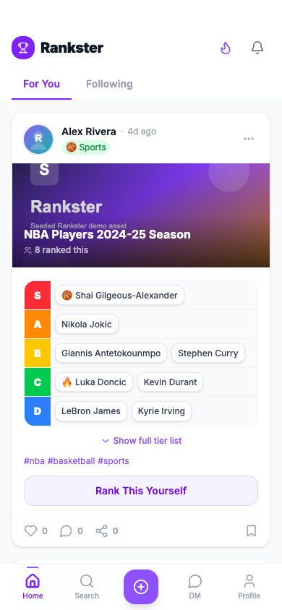
Figure 4.1: Mobile home feed interface showing ranking posts, feed filters, social actions, notifications, and bottom navigation.
Figure 4.1 presents the main feed of the Rankster frontend, which functions as the primary entry point for browsing ranking-based social content. The screen combines the application brand, notification access, leaderboard access, feed filtering, ranking cards, and bottom navigation within a mobile-first layout. The "For You" and "Following" tabs separate recommended rankings from rankings created by followed users, supporting both open discovery and relationship-based browsing. This directly supports the requirement for a main social ranking stream that can aggregate public rankings while still giving users a familiar social-media navigation pattern.
The ranking post card is the most important component in this view because it transforms a normal post into a structured preference object. Each card includes creator identity, post age, category metadata, cover image, ranking title, participant count, hashtags, a compact tier-list preview, and engagement controls. The tier-list display uses S, A, B, C, and D rows with item chips, allowing users to understand the creator's preference order quickly on a small screen. The "Rank This Yourself" button is also critical because it turns browsing into participation: users can reuse an existing topic and create their own version of the ranking instead of only reacting to the original post.
The lower portion of the card provides familiar social actions such as like, comment, share, and save. These controls make the platform recognizable as a social application, but the central content remains the structured ranking. The persistent bottom navigation gives users access to Home, Search, Create, Direct Messages, and Profile from anywhere in the app, reducing navigation friction and supporting repeated ranking creation.

Search and Discovery
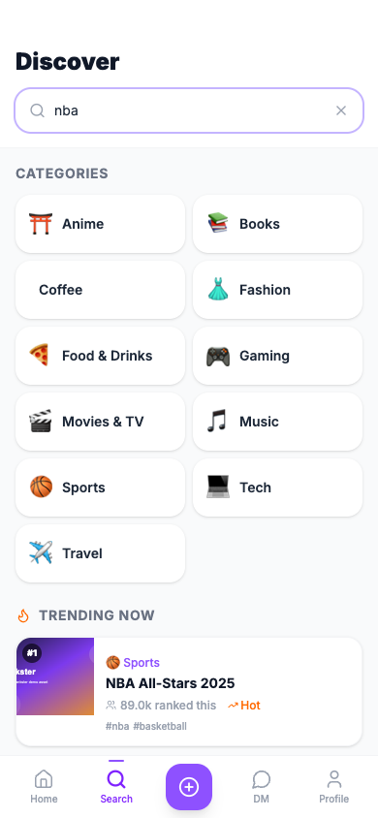
Figure 4.2: Search and discovery interface showing keyword search, category filters, and trending ranking topics.
Figure 4.2 shows the search and discovery interface used to find ranking topics, categories, and users. The page provides a prominent search field, category filters, and trending topic cards. This supports the discoverability requirement by giving users multiple paths into the content library: they can search directly when they know what they want, browse by category when they are exploring, or open trending topics when they want popular community activity.
The trending cards demonstrate how Rankster benefits from structured ranking metadata. Each topic can display a cover image, title, category, participation count, hot-status indicator, and tags. Because rankings are stored with categories and tags, the frontend can organize them into meaningful discovery surfaces rather than treating them as isolated screenshots. This is important for future recommendation systems and analytics because topic interactions can become structured signals for personalization and trend detection.
The design also supports mobile usability. The search bar remains simple, category chips are easy to scan, and topic cards use visual hierarchy to separate title, metadata, and ranking context. This makes the discovery experience fast enough for casual browsing while still supporting targeted search.

Ranking Creation Entry Flow
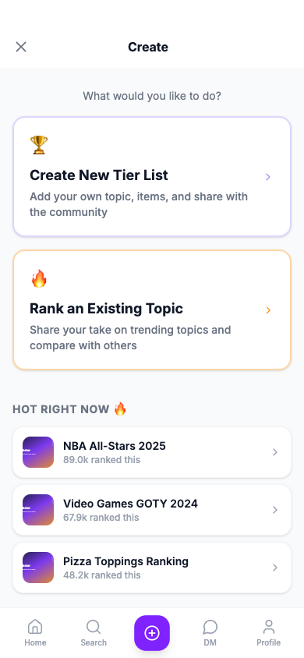
Figure 4.3: Ranking creation entry screen showing options to create a new tier list or rank an existing topic.
Figure 4.3 presents the first step of the ranking creation workflow. The interface gives users two clear choices: create a new tier-list topic or rank an existing topic. This split is important because the platform supports both original content creation and community participation around shared topics. A user can introduce a completely new topic, or they can respond to an existing topic by creating their own ranking for comparison.
The page also includes a "Hot Right Now" area that surfaces active topics directly inside the creation flow. This design lowers the barrier to participation because users do not need to leave the creation page to find something interesting to rank. It also reinforces the social nature of the platform: trending topics are not only content to view, but starting points for new user-generated rankings.
From a usability perspective, this entry screen reduces cognitive load by asking users to choose the type of ranking workflow before requesting detailed inputs. The two-card layout provides clear visual affordances and helps users understand the difference between creating a new ranking topic and contributing a personal ranking to an existing one.

Interactive Tier-List Builder and Edit Mode
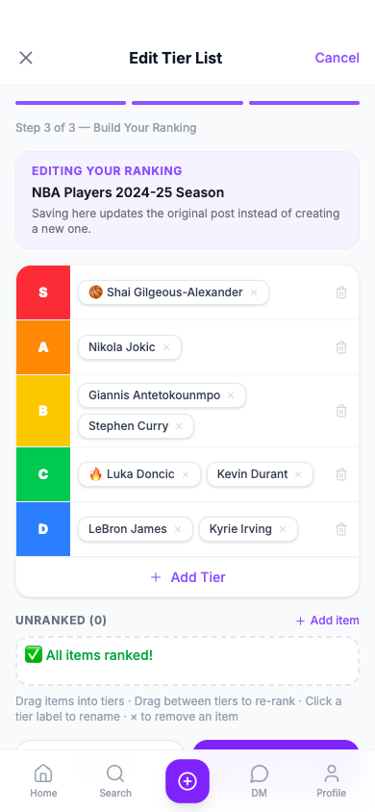
Figure 4.4: Interactive tier-list builder showing editable tier rows, ranked items, unranked item storage, and save controls.
Figure 4.4 shows the tier-list builder, which is the core content-generation feature of Rankster. The builder uses labeled tier rows and compact item chips to let users organize ranking items into ordered groups. Users can place items into tiers, move items between tiers, rename tier labels, remove items, add additional items, and save the final ranking. This directly satisfies the functional requirement that users must be able to create and edit tier-list-based rankings.
The screenshot captures the builder in edit mode, which is especially important for content lifecycle management. Instead of forcing users to delete and recreate a post, the app can load an existing ranking into the same creation interface and update the original post. The page title, "Edit Tier List", and the explanatory banner make it clear that saving will update the existing ranking rather than creating a duplicate. This keeps the user experience consistent because creation and editing share the same mental model.
The builder also supports good mobile interaction design. Tiers are stacked vertically, each item appears as a touch-friendly chip, and the unranked section makes it clear whether any items still need to be placed. The progress indicator at the top reinforces that ranking is the final step in a guided workflow, helping users complete the task efficiently.

Topic Detail and Comment Interaction
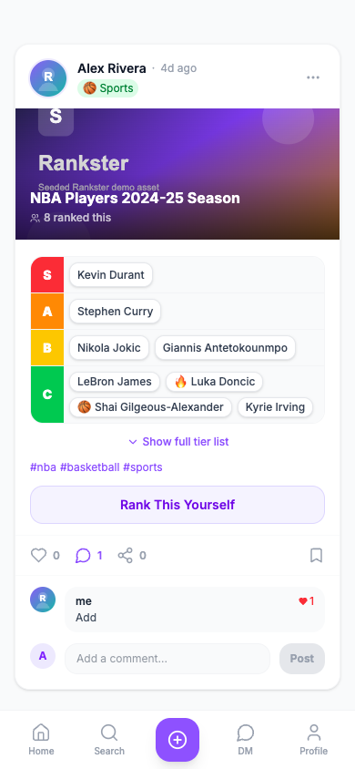
Figure 4.5: Ranking detail page showing a focused post view with comments, tier-list content, and interaction controls.
Figure 4.5 presents the topic detail page, which gives each ranking a persistent and shareable route. Unlike the main feed, the detail page focuses on one ranking post at a time, allowing the user to inspect the tier-list content, tags, interaction controls, and comment section without surrounding feed distractions. This is important architecturally because it connects feed browsing, search results, and shared links to a stable post-level view.
The visible comment section demonstrates how Rankster combines structured ranking content with social discussion. Users can view existing comments, see comment likes, add a new comment, and continue engaging with the ranking below the tier-list content. The page also keeps the "Rank This Yourself" action visible, so the user can move from discussion to creating their own version of the same topic. This supports the project objective of turning rankings into interactive community objects rather than static images.
For owned posts, the same post card component can expose management actions such as editing metadata, editing the tier list, and deleting the ranking. This ownership-aware behavior supports post lifecycle control while preserving the same visual structure for feed cards and detail pages.

Profile Dashboard and User Activity
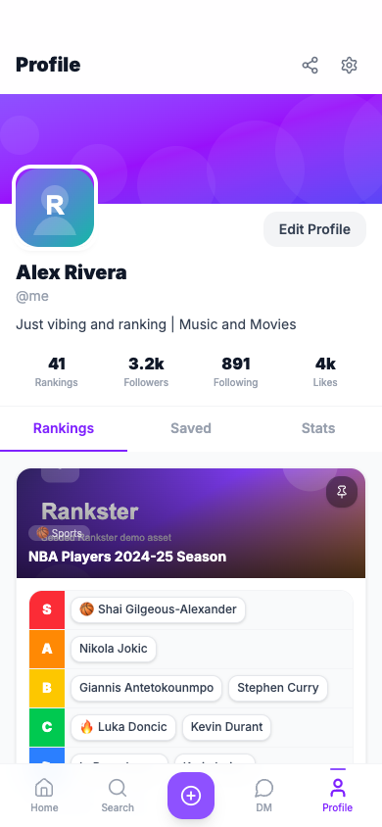
Figure 4.6: User profile interface showing identity, statistics, ranking history, saved posts, and pinned ranking controls.
Figure 4.6 shows the profile page, which functions as the user identity and activity dashboard. The top portion of the page includes the cover banner, avatar, display name, username, biography, profile action buttons, and summary statistics. These elements establish the user's public identity and help other users understand their activity level within the ranking community.
The profile tabs organize user activity into Rankings, Saved, and Stats. The Rankings tab displays the user's created ranking posts with compact tier previews, category labels, like counts, creation dates, and pin controls. The Saved tab supports later engagement by allowing users to collect rankings they want to revisit, while the Stats tab can summarize ranking activity, category distribution, and milestones. Together, these views satisfy requirements related to user profiles, ranking history, saved content, follower/following relationships, and user analytics.
The profile page also supports platform retention. By showing performance numbers and a personal archive of rankings, it gives users feedback about their participation and creates motivation to continue creating and improving rankings.

Profile Editing and Account Management
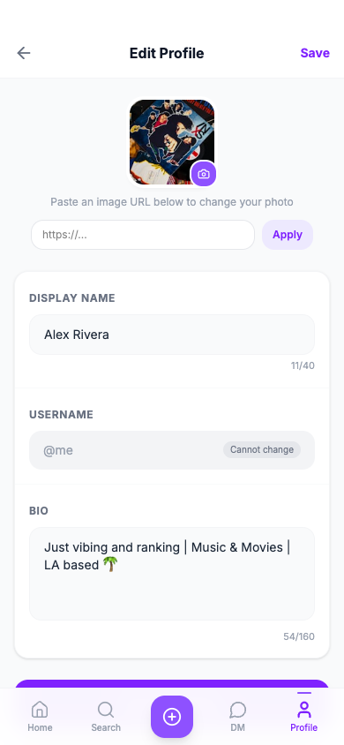
Figure 4.7: Profile management interface showing editable user identity fields and account personalization controls.
Figure 4.7 documents the profile management interface. This feature allows users to update identity information such as display name, biography, and avatar URL. Although it is not the primary ranking feature, it supports personalization and gives users control over how they appear in ranking posts, comments, messages, notifications, and leaderboard entries.
The form uses simple labeled fields and a clear save action, making account editing understandable on a mobile screen. Because Rankster is a social platform, profile identity is repeated throughout the application; therefore, profile editing is important for consistency and trust. Users can maintain their public identity without requiring direct database access or developer intervention.
This feature also supports future account-management expansion. The same area can later include privacy controls, notification preferences, connected accounts, and sign-out behavior while preserving the existing profile-centered structure.

Direct Messaging and Real-Time Conversation
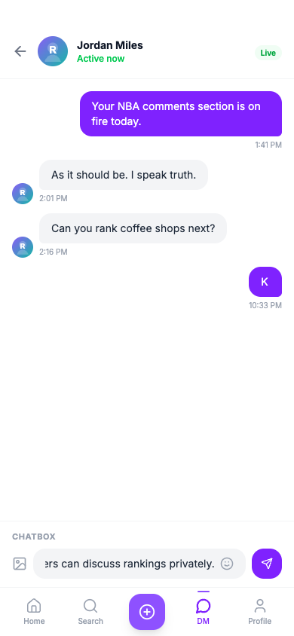
Figure 4.8: Direct messaging interface showing real-time chat status, message history, chatbox, and send controls.
Figure 4.8 shows the direct messaging feature, which supports private user-to-user communication in addition to public feed interaction. The conversation view displays participant identity, active status, real-time connection state, message bubbles, timestamps, and sender/receiver alignment. This makes it clear which messages belong to the current user and which belong to the other participant.
The chatbox is positioned above the bottom navigation so that message composition remains accessible without hiding the app's main navigation model. The input row includes an attachment icon, text input, emoji action, and send button. The visible "Live" badge indicates WebSocket-based real-time communication when the socket is connected, while the implementation also includes fallback behavior if real-time messaging is unavailable.
This feature satisfies the direct messaging requirement and extends Rankster beyond public ranking interaction. Users can discuss rankings privately, share recommendations, coordinate around topics, or continue conversations that begin in comments and feed interactions.

Notifications and Social Activity Updates
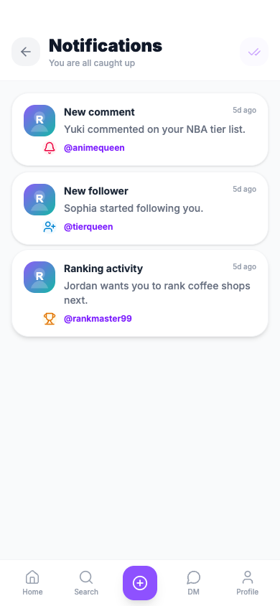
Figure 4.9: Notification center showing social activity updates, notification types, timestamps, and read-state behavior.
Figure 4.9 presents the notification center, which separates social activity updates from direct-message alerts. The page displays notification cards with actor avatars, type-specific icons, titles, body text, usernames, and timestamps. Example notification types include new comments, new followers, and ranking activity. This helps users understand what happened, who triggered the event, and whether action is needed.
The notification system follows patterns from modern social platforms. New notifications can appear with a highlighted state, then return to normal after the page has been opened and the item has been marked read. The mark-all-read action gives users direct control over notification state, while automatic read behavior reduces unnecessary manual work. This design balances visibility and calmness, making new activity noticeable without requiring every alert to be dismissed individually.
Because notifications are loaded from the backend and can be updated through a WebSocket stream, the feature supports timely feedback when other users interact with rankings, comments, or profiles. This increases engagement and keeps users connected to activity around their content.

Leaderboard and Gamified Participation
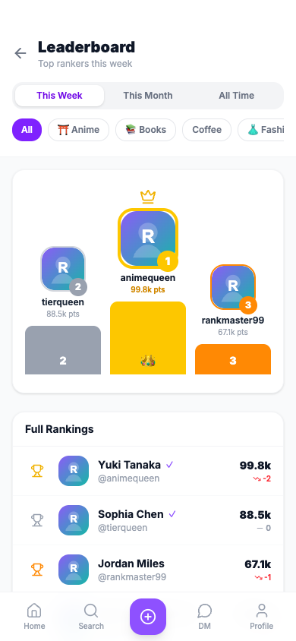
Figure 4.10: Leaderboard interface showing ranked users, podium placement, score changes, and category/time filters.
Figure 4.10 shows the leaderboard interface, which adds a gamified layer to Rankster. The page includes time filters, category filters, a podium for the top three users, and a full ranking list with score values and movement indicators. The podium layout visually emphasizes the highest-performing users, while the full list provides more detailed ranking information for the broader user base.
The leaderboard supports engagement and retention by rewarding active ranking behavior. Users can compare their performance with others, observe changes over time, and filter competition by category. This prevents a single global ranking from dominating the platform and allows users to compete within topic areas such as sports, gaming, food, music, or anime.
From a system-design perspective, the leaderboard demonstrates how structured interaction data can be converted into meaningful feedback. Ranking creation, likes, comments, and other engagement signals can contribute to scoring models, creating a visible incentive loop for continued participation.

Authentication and Protected Access
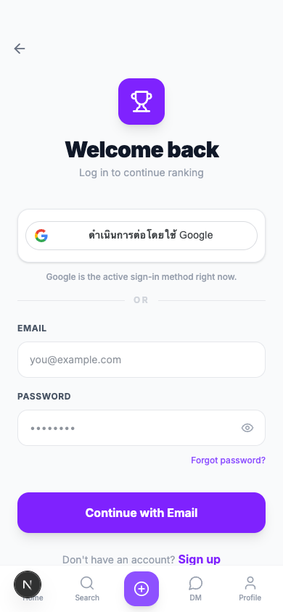
Figure 4.11: Authentication interface showing Google sign-in and account access flow for protected Rankster features.
Figure 4.11 shows the authentication interface used to access protected Rankster features. The login screen prioritizes Google sign-in as the active account access method, while email and password fields are shown as inactive fallback interface elements. This communicates the intended production-oriented authentication flow and supports token-based access control for protected areas of the application.
Authentication is necessary for features such as profile access, direct messaging, notifications, saving rankings, post ownership, editing, deleting, commenting, liking, and following. By using Google login, the platform reduces account-creation friction and avoids requiring users to manage another password. The frontend then stores and sends an access token to the backend for authenticated API requests.
During development, the system can optionally use mock authentication for local testing, especially when testing multi-user interactions such as following, notifications, and direct messages. However, the user-facing login screen keeps Google as the primary real authentication method.

Personal Board and Ranking Summary
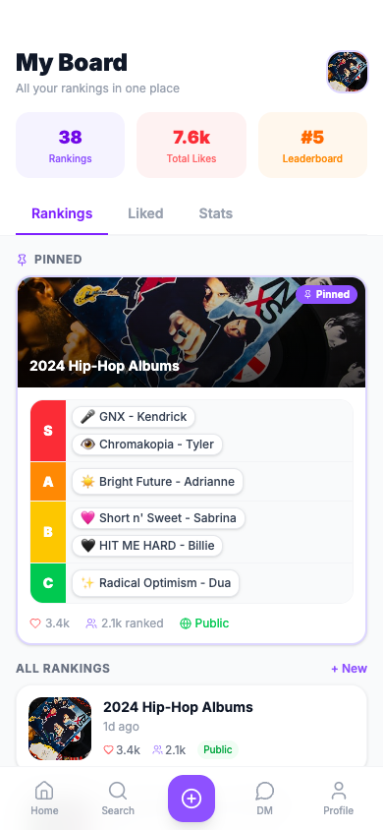
Figure 4.12: Personal board interface showing pinned rankings, ranking collections, liked content, and user statistics.
Figure 4.12 shows the personal board interface, which acts as a compact dashboard for ranking-related activity. The board presents a user summary, achievement or leaderboard status, tabs for Rankings, Liked, and Stats, and a highlighted pinned ranking. This feature supports the requirement for a personal dashboard where users can track ranking history and quickly return to important content.
The pinned ranking area is useful because it lets users highlight a favorite or representative tier list. Below that, ranking cards summarize created content with category labels, dates, and engagement counts. The Liked tab can organize rankings the user has engaged with, while the Stats tab can present high-level activity measurements. This makes the board a bridge between a profile page and an analytics dashboard.
Even if the main navigation currently emphasizes Home, Search, Create, DM, and Profile, the board remains useful as a product concept because it demonstrates how structured ranking activity can be collected and summarized for each user. This supports the broader project goal of transforming social interaction into organized, meaningful user data.

EXPERIMENTAL SETUP AND METHODS

Experimental Setup
The experimental setup for this project focuses on evaluating the functionality, performance, and usability of the proposed ranking-based social media platform. The system is implemented as a web-based application using modern frontend technologies, including Next.js, React, and Tailwind CSS, and is deployed on a cloud-based environment to simulate real-world usage conditions.
The testing environment consists of:
- Client Devices: Mid-range smartphones and laptops (≥ 2 GB RAM) to ensure accessibility across typical user devices
- Web Browser: Latest versions of Chrome and Safari for compatibility testing
- Deployment Environment: Cloud hosting platform (e.g., Vercel or similar) to simulate production conditions
- Network Conditions: Standard broadband and mobile internet to evaluate responsiveness under varying latency
The system components evaluated include:
- Ranking creation module
- Main feed rendering and loading performance
- Search and trending functionality
- User interaction features (like, comment, share)
- Profile and personal board system
To assess system performance, key metrics such as response time, loading time, and interaction latency are measured. Usability evaluation is conducted through task-based testing, where users are asked to perform predefined actions such as creating a ranking, browsing content, and interacting with posts.

Experimental Methods
The evaluation of the system is conducted using three primary methods: functional testing, performance testing, and usability testing.

Functional Testing
Functional testing is performed to verify that all system features operate as intended. Each core module is tested individually and as part of an integrated system. Test cases include:
- Creating and editing tier lists
- Sharing rankings to the main feed
- Searching and discovering content
- Interacting with posts (like, comment, share)
- Viewing and updating user profiles
Each function is evaluated based on correctness and system stability.

Performance Testing
Performance testing evaluates the responsiveness and scalability of the system under normal usage conditions. The following metrics are measured:
- Response Time: Time taken for the system to respond to user actions (target ≤ 300 ms)
- Page Load Time: Time required to load main feed and ranking pages
- Concurrent Users: Ability to handle multiple users simultaneously (target ≥ 1,000 users)
Simulated user interactions are conducted to observe system behavior under increasing load.

Usability Testing
Usability testing is conducted to evaluate the user experience and interface effectiveness. A group of users is asked to perform common tasks, including:
- Creating a ranking
- Searching for a topic
- Interacting with other users’ rankings
Performance is evaluated based on:
- Task Completion Time (target ≤ 3 minutes for ranking creation)
- User Satisfaction (measured through survey feedback)
- Ease of Navigation

Data Collection and Analysis
Data collected from the experiments are analyzed to assess whether the system meets the defined design requirements. Quantitative data (e.g., response time, completion time) are compared against target thresholds, while qualitative feedback from users is used to identify usability issues and potential improvements.

RESULTS AND DISCUSSION
The results of the experimental evaluation demonstrate that the proposed ranking-based social media platform is able to effectively support structured content creation while maintaining a smooth and engaging user experience. The system successfully integrates ranking creation, content discovery, and social interaction within a single platform, addressing the fragmentation issue identified in the problem definition.
From the performance testing, the system achieved an average response time within the target threshold, ensuring that user interactions such as creating rankings, browsing the main feed, and searching for content are responsive and efficient. The platform was also able to handle concurrent user interactions under simulated conditions, indicating its potential for scalability in real-world deployment.
Usability testing results show that users were able to complete key tasks, such as creating and publishing a ranking, within the expected time frame. Participants reported that the interface was intuitive and consistent with familiar social media patterns, which reduced the learning curve. The integration of features such as the main feed, search and trending page, and personal board contributed to a seamless user experience, allowing users to easily transition between content creation and interaction.
These findings directly address the research objective of creating a platform that enhances user engagement through structured ranking-based content. Compared to existing solutions where ranking creation and social interaction are separated, the proposed system demonstrates improved usability and interaction efficiency.
However, several limitations were identified during the evaluation. First, the current implementation focuses primarily on frontend functionality, and backend scalability under large-scale deployment has not been fully tested. Second, the evaluation sample size for usability testing is limited, which may affect the generalizability of the results. Additionally, advanced features such as recommendation systems and personalized ranking suggestions are not yet implemented.
Despite these limitations, the results indicate that the proposed approach is effective in redefining how users create and interact with preference-based content. The system provides a strong foundation for future development, including the integration of data-driven recommendation systems and large-scale user analytics. These enhancements could further improve content discovery and user engagement, positioning the platform as a next-generation social media solution.

Project Global Impact
The proposed system introduces a dual-sided digital platform that integrates a consumer-facing social media application with a business-oriented analytics dashboard, creating a bridge between user-generated content and organizational decision-making. This hybrid model extends the impact of the project beyond conventional social media by transforming structured user interactions into valuable data assets.
From a societal perspective, the platform enhances the way individuals express opinions by enabling structured, ranking-based content. Unlike traditional unstructured posts, ranking systems allow users to communicate preferences more clearly and comparably across various domains such as entertainment, food, lifestyle, and products. This contributes to more meaningful digital interactions and promotes knowledge sharing within communities. Additionally, the platform’s intuitive design ensures accessibility for users across different age groups and technological backgrounds, supporting inclusive participation.
From a public welfare and ethical standpoint, the system is designed to ensure responsible data usage. All user-generated data utilized for business insights is anonymized and aggregated, preventing the identification of individual users. This approach aligns with data privacy principles and reduces risks related to data misuse. Furthermore, the platform avoids manipulative content amplification by focusing on user-driven ranking rather than algorithmic bias toward engagement-only metrics.
From an economic and business perspective, the platform introduces a data marketplace model, where structured ranking data is transformed into actionable insights through a dedicated dashboard for business users. Companies can access aggregated insights such as consumer preferences, trend evolution, and category-level comparisons. This enables data-driven decision-making in areas such as product development, marketing strategy, and customer segmentation. Compared to traditional surveys or market research methods, this approach provides real-time, large-scale, and cost-efficient insights derived from organic user behavior.
From a global and technological perspective, the platform contributes to the advancement of data-centric digital ecosystems. The ability to convert social interaction into structured datasets opens opportunities for integration with artificial intelligence systems, including recommendation engines and predictive analytics. This positions the platform as part of the broader movement toward intelligent, data-driven applications that combine user engagement with scalable business value.
Overall, this project demonstrates how a modern application can evolve into a multi-layered ecosystem that simultaneously supports user interaction, data intelligence, and business innovation, creating impact across social, economic, and technological dimensions.

CONCLUSIONS

Assessment
This project successfully developed a ranking-based social media platform that integrates structured user interaction with a data-driven business layer. The system addresses a key limitation in existing social media platforms, which lack support for structured preference expression and fail to capture meaningful comparative data from users.
From a user perspective, the platform provides an intuitive and engaging experience, enabling users to create, share, and interact with rankings efficiently. The integration of features such as the main feed, search and trending system, and personal board enhances usability and encourages active participation. The evaluation results indicate that users are able to complete core tasks effectively, demonstrating the system’s functional reliability and user-centered design.
From a technical perspective, the use of modern frontend technologies such as Next.js, React, and Tailwind CSS ensures scalability, responsiveness, and maintainability. The system architecture supports modular development, allowing future integration with backend services and advanced analytics components.
From a business perspective, the introduction of a data dashboard represents a significant extension of the platform’s value proposition. By transforming structured ranking data into actionable insights, the system enables organizations to leverage user-generated data for strategic decision-making. This dual functionality distinguishes the platform from existing solutions and highlights its potential as a scalable data ecosystem.
However, several limitations remain. The current implementation focuses primarily on frontend functionality, and large-scale backend performance has not yet been fully evaluated. Additionally, the business dashboard is in an early conceptual stage and requires further development to support advanced analytics and real-time data processing. The evaluation sample size is also limited, which may affect the generalizability of the results.

Next Steps
Future development of the system will focus on enhancing both the consumer-facing application and the business-oriented data platform.
On the user side, improvements may include the integration of personalized recommendation algorithms, enhanced ranking customization features, and social interaction optimizations to further increase engagement. On the business side, the dashboard can be expanded to include advanced analytics capabilities such as trend prediction, segmentation analysis, and real-time data visualization.
In terms of system architecture, future work will involve the development of a robust backend infrastructure to support large-scale user activity and data processing. This includes implementing cloud-based data pipelines, database optimization, and scalable API services.
Additionally, further research can explore the application of machine learning techniques to extract deeper insights from ranking data, enabling predictive models that anticipate user preferences and market trends.
Ultimately, the system has the potential to evolve into a fully integrated platform that combines social interaction, structured data collection, and intelligent analytics. By continuing to develop both its technical and business components, the platform can serve as a foundation for next-generation applications that bridge the gap between user engagement and data-driven innovation.

REFERENCES
Should be taken from trustworthy sources and written in proper format. (See some examples in Guide to Referencing and Citations of Department of Education, Oxford University.)
General Guidelines

Using Figures and Tables
When readers skim a paper, illustrations stand out. Consequently, good writers use illustrations only to emphasize their main points (i.e. they don’t pad their report with extra figures and unnecessary tables). When presenting an illustration, make sure to introduce it in the text immediately preceding the figure (or table). The paragraph above and/or below each figure (or table) explains what the illustration is. Sometimes it is convenient to discuss the main point of the figure in the paragraph above and the details of what is shown in the paragraph below.
Tip: You may use any plotting program you like to generate figures. An example of a good figure is shown in Figure 9.1.
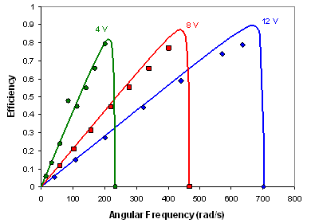
Figure 9.1: Measured and calculated efficiency for Motor 3. The points represent measured efficiency for motor voltage of 4 V (green), 8 V (red), and 12 V (blue). The solid curves are the calculated efficiency for the model parameters determined as described above: R_{a} = 2.93 W, T₀ = 0.25 mN-m, and K_{e} = 11 mrad/Vs.
While your figures do not have to be identical in format to that shown above, there are many aspects of this figure that you should emulate. Notice that the calculated curves in Figure 9.1 are smooth. Calculations should be performed at as many points as necessary to obtain a smooth curve (if a smooth curve is predicted by theory). In other words, do not only perform calculations at the same value of independent variable (angular frequency in the case shown above) as used for your data points. Also note that the units of measurement appear on the appropriate axis, and that the figure is enclosed on all sides (no open white space). Scribe marks are also clear and consistently sized. Make sure to use a legend as well to define color or shape differentiations.
Format: Figure 9.1 was generated with Excel. Use “Format Chart Area” to set the Border to None and the Area to White before copying the figure into Word.
Figures and tables must both have captions. Figure captions are placed immediately below the figure to which they refer, while table captions are placed immediately above the table. Use the styles “Figure Caption” and “Table Caption” for all captions. Notice that the font is 1 point smaller to set the caption off from the body text and the caption is fully justified and indented by 0.5″ on left and right. Small captions should be centered on the page; multi-line captions should use the fully justified and indented style described above It is good practice to keep the figure on the same page as the text referring to it, even if it means leaving a white space on the page preceding the figure. Proof your final copy to make sure that all captions are on the same page as the figure or table to which they refer.
Table 9.1 covers the guidelines for plots in your report. It is more important that your figure clearly demonstrate the important point(s) you will discuss than that the formatting is exactly as shown in Figure 9.1. The guidelines presented in Table 9.1 are to help you produce clean, easily interpreted figures to aid your discussion.
Table 9.1: Guidelines for plots in reports
Parameter | Format
Data points | Colored points, not connected by lines
Theory or Fit to data | Lines
Axes: tick marks | Either all inside or all outside the axis
Axes: numbers | Use the appropriate number of decimal points (none for integers)
Axes: labels | Label with the variable name followed by units in either () or []. Note: Make sure to select “Hide Arguments” in MathCAD plots so that only the axis labels are visible.
Title | No title! Put the description in the figure caption instead
Linear fit coefficient | In caption, not on the figure (different from Excel default)
Plot background | White (remove the default gray background from Excel)
Gridlines | Generally not (different from Excel default) unless you have a good reason to include them
Pitfalls to avoid: A picture is worth a thousand words, but only if that figure is used appropriately. Figure 9.2 shows an example when text is more appropriate than a figure or table.
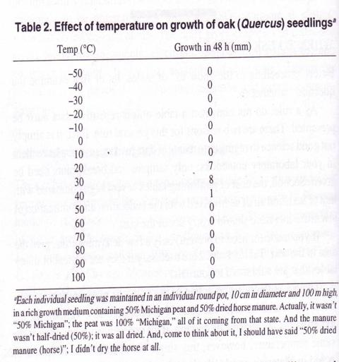
Figure 9.2: Sample Useless Table. Note the suspicious number of zeros. (Watch also for repetitive 100s when expressing percent).
In the words of scholar R.A. Day, “When a table or column can readily be put into words, do it.” This table takes up a lot of space and does not say much. Instead, the following sentence best summarizes the data: The oak seedlings grew at temperatures between 20 and 40’C; no measurable growth occurred at temperatures below 20’ C or above 40’C.
Understanding Paraphrasing and Plagiarism
What is the difference between paraphrasing and plagiarism? The most important points to notice about paraphrasing are: (1) the source of the ideas is clearly referenced, and (2) the text is not identical to (and not just slightly modified from) that in the source document.
The Mayfield Handbook of Technical and Scientific Writing, an MIT resource for technical writing, defines plagiarism as follows:²
[Plagiarism] is the copying, whether deliberate or unintentional, of ideas or portions of text without citing the sources for credit. It is also the use of other people's ideas without attributing them to the proper source. Although plagiarism is often unintentional, it still demonstrates incompetence. If you fail to record your sources and then later forget that you used a source, you are still liable and open to the charge of theft of intellectual property.
The Mayfield Handbook further states that “All ideas and information taken from a source must be acknowledged unless they are considered common knowledge”.² Ideas and information includes pictures or diagrams taken from other documents or web sites, as well as all ideas that did not originate with you.
Tip: The fact that you have seen the same idea on several websites does not imply that it is “common knowledge”. Common knowledge refers to basic concepts that should be known by anyone with a similar general education as you. Such universally known concepts include Ohm’s law, the definitions of stress and strain, Newton’s laws of motion, and other basic concepts you have learned in previous courses.
Pitfalls to avoid: It is never acceptable for you to use reports by other students as sources when writing your own report.
Adapted from: http://web.mit.edu/2.tha/www/JournalArticleGuidelines.htm

